Rotary Club of Cooma Inc
July Theme:
The New Rotary Year
12 July 2017
Guest Speaker – Graham West
ROTARY

Web address: coomarotary.org.au
Email
bulletin@coomarotary.org.au

Meeting statistics:
Attendance: 78.8%
Guests: Graham West (club), Daud Mahomed, Fr Mick Mac Andrew, Kate Grimstad (Hass)
Apologies: Brad, Peter, Kevin, Jan
Leave: Meg, Tom, Joe

July dates:
Birthdays: Tony 8/7, Christine (Wolfgang) 12/7, Helen 17/7
Anniversary: Meg and Tom 14/7
Date joined Rotary: Peter 1/7, Helen 6/7

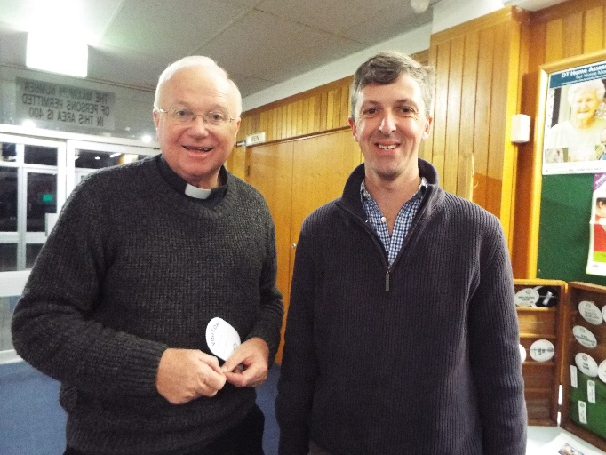

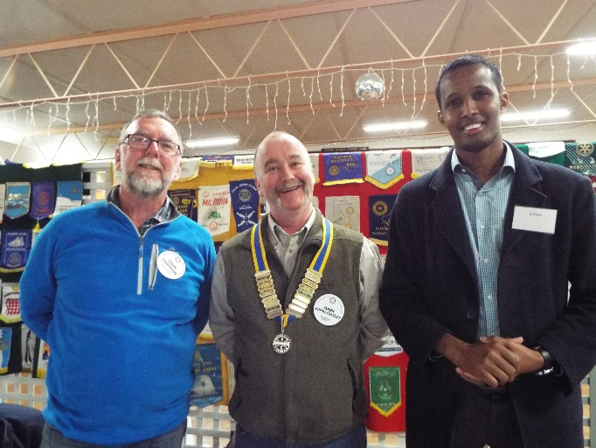

NOTICES:

Dugald: The current balance sheet for the club’s finances is available. The final results for the year will be audited in November. It is pleasing that much of the money that has been raised during the year has been given to worthy causes, particularly locally. A very big thank you to Darrell for all his help as assistant treasurer.

Hass: From now on, the bulletin will be available through a web link instead of an attachment. (coomarotary.org.au/newsletters)

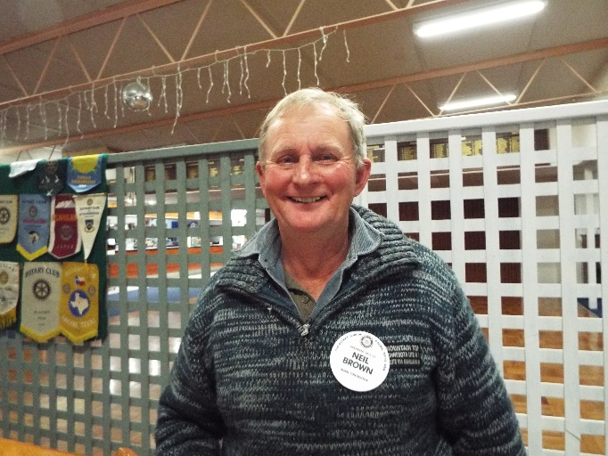

THREE MINUTER:
Neil spoke about a cave system on his property, ‘Cloyne’, at Chakola. As a Venturer, a senior scout, he experienced some great activities including caving. The Cloyne cave, technically a wild cave, has been formed by limestone and has beautiful crystals on the cave wall. Ironstone, a result of the basalt soil, has leached through and now there is a lot of rusty red colour. Where the crystals are untouched by the red, the pure white crystals take on the appearance of cauliflowers.
The cave runs from one main chamber into a fault line, into two smaller chambers and then into a flow stone. There are several entrances into the cave system, some of them being vertical drops. Ingress is assured but exit is not!
In the 70s the Sydney Speleological Society investigated the cave.

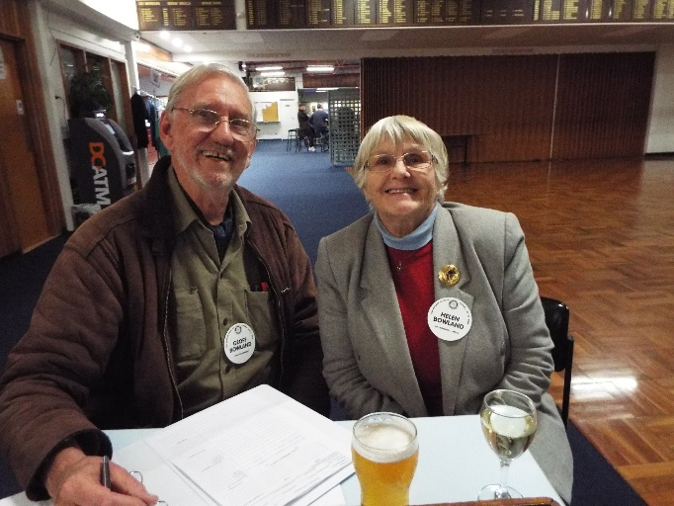

ROSTERS - July
Attendance: Helen, Geoff
Fellowship: John Ch, Brad
Property: Darrell, Sue S
3 Minuter: 19/7 Peter 26/7 Jan
Intro: 19/7 Marco 26/7 Dave B
Thanks: 19/7 Dugald 26/7 Ken
Thought: 19/7 Kevin 26/7 Hass
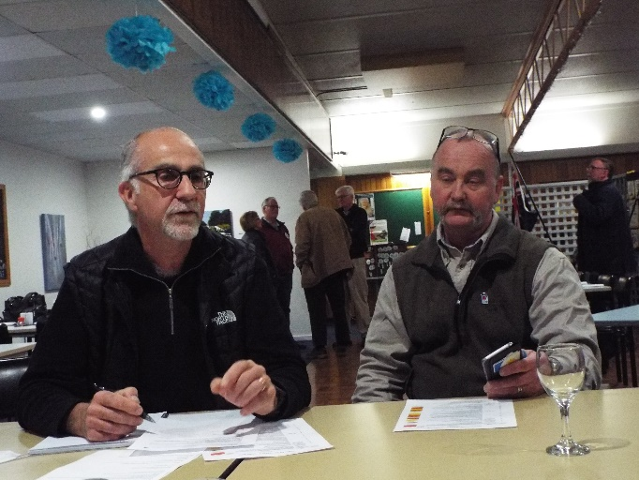
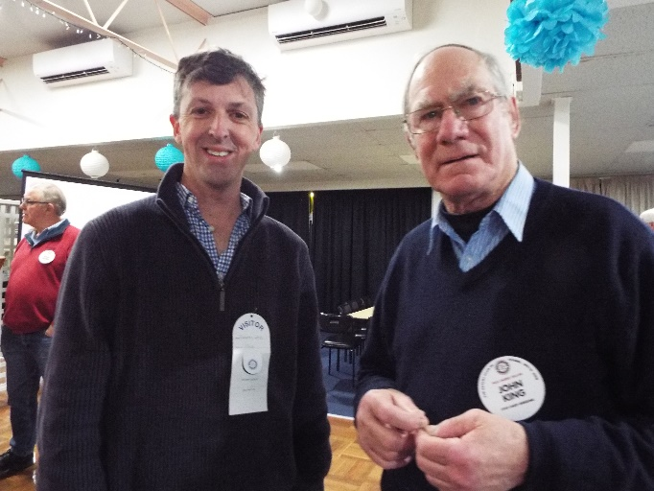

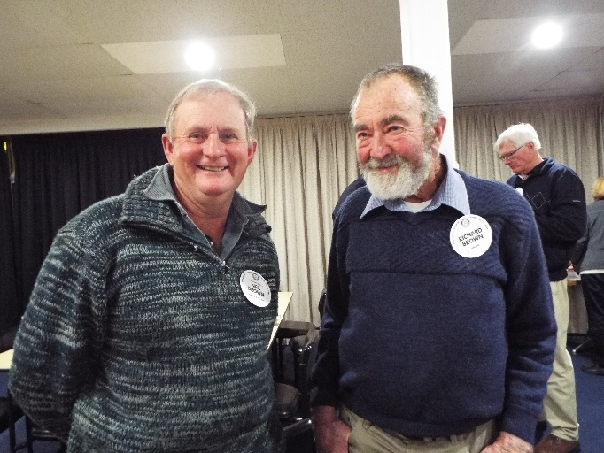

THOUGHT OF THE WEEK: Mark C
No one notices your tears, no one notices your sadness, no one notices your pain, but everyone notices your mistakes.

Ash thanked the club for the previous meeting when we celebrated Brenda and Ash’s coming wedding.

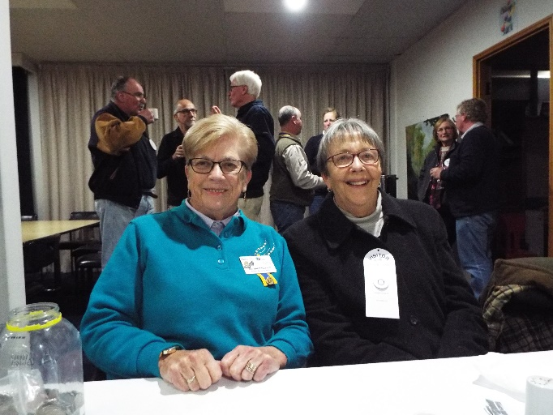
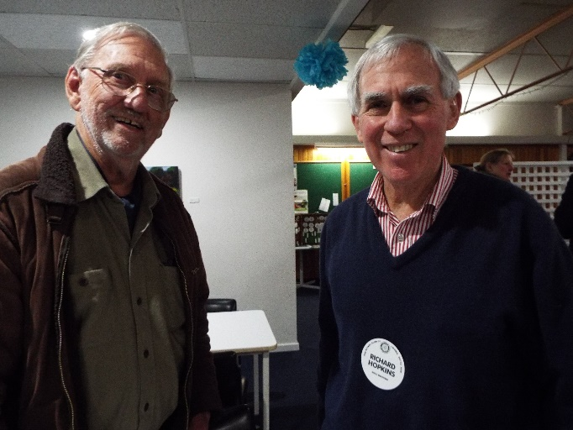
Kate Grimstad represented the local conference of the St Vincent de Paul Society.

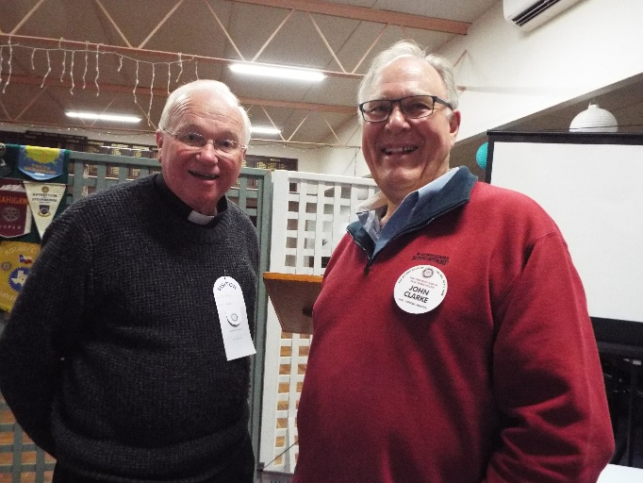

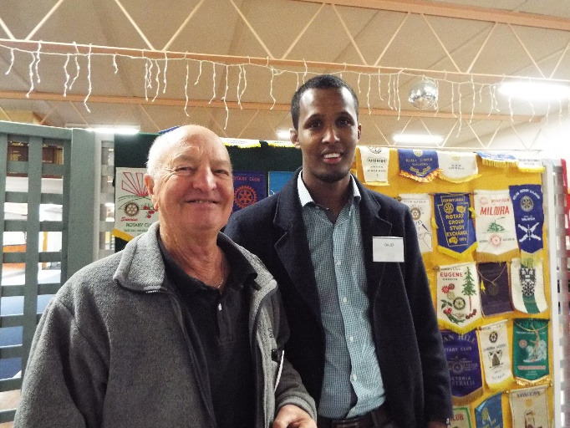
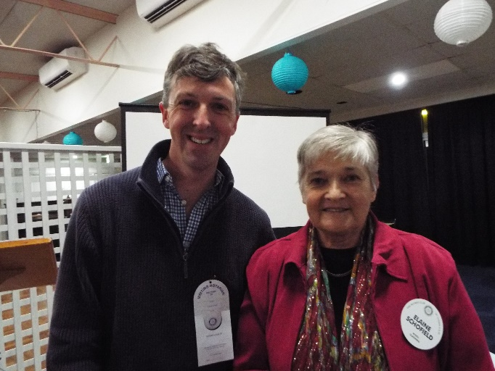

GUEST SPEAKER: Graham West, National President of the St Vincent de Paul Society and a member of the International Council of the Society

St Vincent de Paul was founded in 1833 by a young man in Paris, Frederic Ozanam, and is now in 149 countries. Ozanam was a uni student who used to debate with socialists about the merits of the Catholic Church and was once challenged about what had been done for the people. This challenge spurred him into action and with six friends he collected some firewood to deliver to a needy household. These seven men had experienced a sheltered upbringing and had never associated with poverty. They were really daunted by the experience, so they delivered the wood and ran. Fortunately a nun, Sister Rosalie Rendu, who had already been working to help the poor, took over guidance of the seven men and the society grew from there, coming to Australia in 1854.

Membership varies from just a few people to very many: in Australia, membership is from 40,000 to 60,000; in Brazil there are 100,000 members and world-wide there are about 700,000 members.

Graham, the sixteenth national president, joined SVDP as a 17-year-old after hearing a speaker at his school. His first service was to deliver vouchers to needy people and then he discovered that it was not just material help that was required but also often the physical presence to listen and share stories with some of the clients of the SVDP. The Society helps about 1 million people every year through helping the homeless, drug and alcohol counselling, community housing, and education centres. Through the Vinnies shops, the Society is one of the biggest retailers and recyclers in the country.

Graham discussed the similarity between SVDP, a Catholic social justice movement, and Rotary. Both organisations are involved in helping people and face similar challenges. He acknowledged the work that Rotary has done in the health area, particularly men’s health, as well as help in some of the developing countries. The average age in SVDP is above 70 and while there are younger groups working for the SVDP through schools, the Society usually loses these young people when they leave school. Market research indicates that the SVDP is held in high esteem because of the work it does, yet attracting members in the <70 age group is difficult.

Graham is grateful to the Society for its help in setting the course of his life and for meeting his wife who was also a member. He has found belonging to it very rewarding.

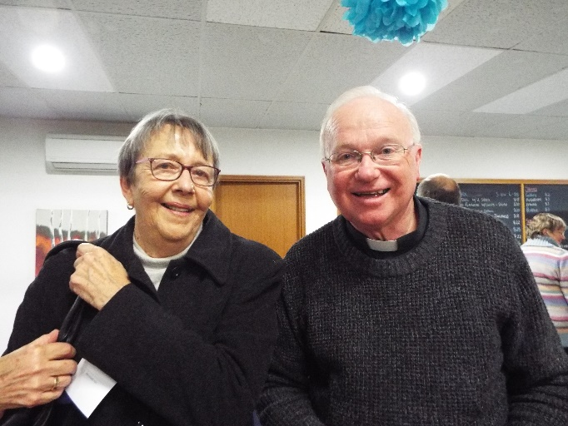

LATE PRESS:
Word has been received of the untimely passing of Sam Owori, the designated Rotary International President for 2018-2019. Sam was a member of the Rotary Club of Kampala in Uganda. Apparently he underwent surgery last week in Dallas and did not recover.
This from PRIVP Anne L. Matthews: "There is not another Sam Owori!! He was a good soul and a great Rotarian. "
As president, he planned to "harness that enthusiasm and pride so that every project becomes the engine of peace and prosperity."
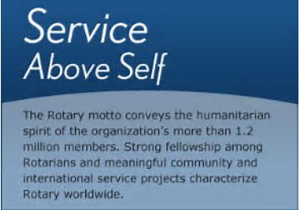

NEXT MEETING: Darrell and Hass speaking about the Atlanta Convention

